# Introduction

Rule Contest Application has been developed for TMO department. It allows gathering user registrations during recruitment events (conferences, job fairs etc.) as well as conducting lotteries with prizes. Below use cases chart presents main functions and module.

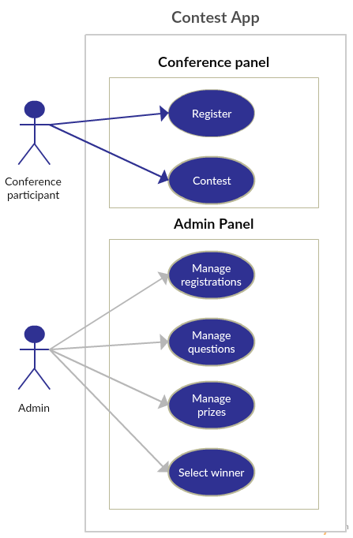

# Application functions

## Conference module

Conference module allows user to select from two options: taking a part in the contest and leaving personal details in order to contact in case of vacancy.

### Taking part in the contest

* Submits form with user contact details
* Shows random technical question from one of three, user-selected categories: Java, SQL, .NET.
* If technical question is answered correctly, lottery service draws small bonus prize and displays it to the user.
* If technical question is answered correctly user is notified that he enters a big prize contest. Big contest prizes are listed.
* User is limited to single registration (identified by unique email address)
* Lottery feature draws a minor bonus prize for everyone that gives correct answer to the contest question. Prize is drawn right after correct answer is submitted. For current contest edition (march 2014) three prize types will be available with given stock and winning chance:

|  |  |  |
| --- | --- | --- |
| Prize | Chance | Stock |
| Spinning Top | 3/6 | 300 |
| USB Hub | 2/6 | 100 |
| Big Mug | 1/6 | 40 |

Every prize type have a probability weight and available stock. Prize is drawn based on number and probability weights of available prizes (positive stock) using algorithm:

* + If prize runs out of stock it is excluded from drawing.
  + Random number is drawn from range between 0 and sum of all probability weights of available prizes.
  + Every prize gets a subrange equal to it's probability weight.

### Leaving personal details

* Submits form with user personal details
* Add information about qualification

## Administration panel

Administration panel allows administrator prepare application for an event and also collect data when event is finished.

### Registrions tab

* shows a table with submitted registrations
* allows removing user registration one-by-one
* allows filtering user registrations
* allows exporting submitted registrations to .xls document

### Questions tab

* shows a table with technical questions
* allows adding technical questions in one of three categories: Java, SQL, .NET using a popup form.
* allows removing questions one-by-one
* allows filtering questions by category

### Winner selection tab

* shows big lottery web page
* allows drawing big prizes one-by-one
* prizes are drawn from users that answered technical question correctly
* prize winners can be identified in .xls document generated by Registrations tab export functionality

### Prize management

* shows a table with big prizes
* allows adding new big prizes
* currently big prize image has to be stored within application package (can’t be uploaded using this form)
* big prize image path is relative to application package root

### Bonus Prize management

* shows a table with small bonus prizes
* allows editing prize quantity and selection probability
* allows editing prize quantity and selection probability